Biography of a Software Engineer – Max Levchin

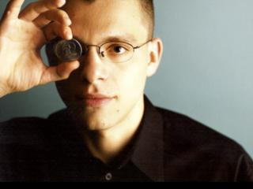

Max Levchin is a very shrewd software engineer, co-founder of PayPal and is also involved in numerous other business ventures. His successes have been ground-breaking and influential in the world of software engineering. The reason I am choosing to do this biography on him is because I actually had the pleasure of meeting him a few years ago at a conference. He gave an inspiring talk which gave me great admiration for all the things he has accomplished in his career to date.

# Background

Born in Kiev, Ukraine in 1975, Max showed a lot of promise from an early age. In an interview with Sarah Lacy, he describes to her that from when he was “conscious enough to speak” that he wanted to become a maths teacher, despite being born into a family of physicists (Lacy, 2018).

The plan for a career as a maths teacher faded when Max was 10 or 11, and was first exposed to computers and programming. Max was given the task to help his mother, a physicist, program on a “soviet clone of a PDP-11”. This is where Levchin’s excitement for this field began, as Max even details sneaking another “clone of the TI programmable calculator” home past his mother. It was at this stage in his life that he had a “profound realization” for coding – that you could tell these machines what you wanted them to do. From here on out, Max wanted to be a computer programmer (Lacy, 2018).

Before this could happen however, Max’s world as he knew it was turned upside down, as was the case with so many others, when the Chernobyl disaster struck in 1986. His mother along with her colleagues in her radiology lab found traces of radiation in food and other commodities coming into Kiev from up north near Chernobyl (Lacy, 2018). Because of this, Max was sent south to Crimea, but eventually the Levchin family left the Soviet Union and headed out west to America.

Levchin had respiratory issues and some doctors didn’t like his chances of living. He started playing the clarinet after being advised by his family to do so, which helped to expand his lung capacity (White, 2020). He also had a close call as a teenager when he set off a Geiger counter, but doctors soon realized it had come from a rose thorn that had made its way into his shoe, rather than radiation in his leg (Lacy, 2018).

The US excited Max due their advances in computers and technology. He quickly adapted to the new culture and way of living with his family settling in Chicago, and soon began college in the University of Illinois. It was here that he earned a bachelor’s degree in computer science in 1997 (White, 2020).

# Career and Accomplishments

Until the age of about 16, Max would develop games such as “Tetris” and “Snake” using only a notepad to write the code (Lacy, 2018). So it was only expected he would go on to do magnificent things once he had the technology that he required. After college he went on to do a thesis in cryptography and data security, which led him to meet Peter Thiel (O'Brien, 2007).

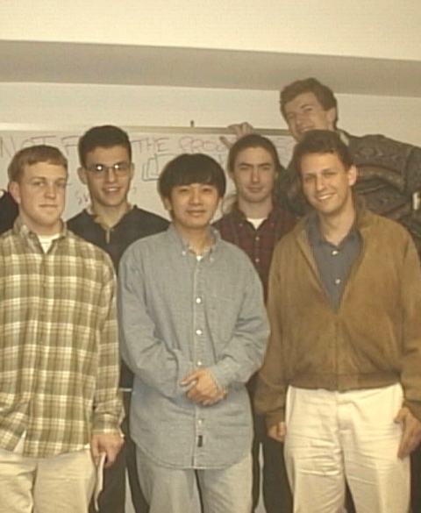**PayPal:** Together Levchin and Thiel worked on handheld devices called PalmPilots. This picture to your right shows both Levchin and Thiel along with the rest of their team in the early stages of developing the PayPal product, who’s main focus was on digital transfer of funds.

A lot this was based off code that Levchin had written as an initial developer for the devices. Levchin’s primary contributions were to PayPal’s anti-fraud efforts, and he was so sure of his own abilities that the initial investment on $6 million was made using PalmPilots (Livingston, 2007) (O'Brien, 2007).

At this point, Max experienced his first encounter with the TV news. After chatting with Reid Hoffman, he realised that the web had a huge audience and a lot of potential customers. So Levchin and his team decided to make a web demo to try and get more users (Lacy, 2018).

They soon started to notice large amounts of money changing hands, and realized that it was coming mainly from eBay. This started the world’s leading person to person payment exchange, and eBay the bought over PayPal for $1.5 billion in 2002 (MIT Review, 2002).

**Slide:** After all his success with PayPal, Levchin went on to start up Slide in 2004. The idea behind it is that supplies a sharing service to social media sites for example Facebook (White, 2020). Despite being sold to Google for $182 million in August on 2010, Max describes this project as a “disappointment”. Slide were “generating revenue and building games”, but it was something that he just had no interest in. Google shut Slide down in 2011, and with that Max rather happily left the company (White, 2020).

**HVF and Affirm:** In 2011, Levchin founded HVF (“Hard, Valuable and Fun”). Having been disappointed with the Slide project, this company was much more up Levchin’s ally.Having heard Max speak mainly about HVF a few years ago, he showed a huge amount of passion for what HVF do, and that is to fund leveraging data projects (White, 2020). This allowed Levchin to create Affirm which is a financial company that he is currently CEO of. On his website he claims that they are going to “remake consumer finance from the ground up” (Levchin, 2020). Customers are able to get small loans, but in real time. This prospect excited Levchin a lot more that the videos as it is something me had a real interest in.

**Investments and other business interests:** Levchin’s other main project is called Glow. This is a pregnancy app that has coding behind it to predict a woman’s menstrual cycle and help them to discover the easiest way to get pregnant. Max was also on the board of directors of Yahoo! and was chairman of Yelp for 11 years (Levchin, 2020).

Levchin’s understanding of data is one of the main reasons that he managed to bridge the gap between himself and other software engineers of his generation. His persistence is also one of his key personality traits. He often talks about his numerous failed business ideas before PayPal kicked off, and claims that this was “plan G” by the time it kicked off. It is this devotion to being a software engineer and tireless work that he has endured that has made him so successful, and is the main reason I admire him so much in his profession (MIT Review, 2002).

# References

Lacy, S. (2018). Working Hard & Staying Humble | Interview with Max Levchin | Founder Story. [online] Startups.com. Available at: https://www.startups.com/library/founder-stories/max-levchin [Accessed 7 Oct. 2019].

Levchin, M., 2020. *Max Levchin*. [online] Levchin.com. Available at: <http://www.levchin.com> [Accessed 13 November 2020].

Livingston, J. (2007). Founders at Work. Apress, pp.1-16.

MIT Review, M. (2002). Innovator Under 35: Max Levchin - MIT Technology Review. [online] MIT Technology Review. Available at: http://www2.technologyreview.com/tr35/profile.aspx?TRID=224 [Accessed 7 Oct. 2019].

O'Brien, J. (2007). The PayPal Mafia. [online] Fortune. Available at: https://fortune.com/2007/11/13/paypal-mafia/ [Accessed 11 Oct. 2019].

Salyers, A. (2016). In Data We Trust: Max Levchin Blows Up Consumer Finance. [online] Mixpanel. Available at: https://mixpanel.com/blog/2016/05/11/max-levchin-rethinks-consumer-finance/ [Accessed 9 Oct. 2019].

White, J., 2020. *About Max Levchin: American Businessman (1975-) | Biography, Facts, Career, Wiki, Life*. [online] PeoplePill. Available at: <https://peoplepill.com/people/max-levchin/> [Accessed 13 November 2020].